**Table of Contents**

**Page**

**Title Page 1**

**Table of Contents 2**

**CHAPTER 1 CHAPTER AND ITS SETTINGS**

**Introduction 3**

**Background of the Study 4**

**Objectives of the Study 7**

**Scope and Limitation 7**

**Significance of the Study**

**CHAPTER 2 CONCEPTUAL FRAMEWORK**

**Review of Related Literature 9**

**Review of Related Studies 20**

**Conceptual Model of the Study 22**

**Operational Definition of Terms 24**

**CHAPTER 3 METHODOLOGIES**

**Project Design 25**

**Project Development 31**

**Operation and Testing Procedure 38**

**Chapter I  
  
THE PROBLEM AND ITS SETTING**

This Chapter contains the introduction, background of the study, objectives of the study, scope and delimitation, and significance of the study.  
  
**Introduction**

Maternity Clinic, also Lying-in Clinic, is an institution in the Philippines that provide excellent maternal services for pregnant women, newborn infants, and promoting reproductive health for the community. It offers maternal services including prenatal checkup, postnatal checkup, delivery or child birth, consultation, immunization, Newborn Screening, laboratory, and Family Planning. Maternity Clinic’s organization must be mainly composed of Midwives, Obstetrician, Gynecologist, and Pediatrician. Midwives, Obstetrician, and Gynecologist are responsible mostly to the maternal services for pregnant patients, while the Pediatrician is the one who manage the health of the child.   
  
 Maternity Clinics are under the Department of Health (DOH) and must secure necessary permits to operate. Some Midwives are affiliated to some associations like the Midwives Association of the Philippines (IMAP, Inc.). IMAP, Inc. was born on 1947 headed by Atty. Angelina C. Ponce where its main visions are to promote highest standards of midwifery practice, enhance the competence of members, reduce maternal and infant mortality, and sustain collaboration and partnership with related agencies.

**Background of the Study**

The Jewel’s First Maternity Clinic is located at 136 Block 8 Zone 2 Brgy. Fort Bonifacio, Taguig City. Its second branch is located at 131, Lot 8, Meralco road Upper Bicutan, Taguig City. It’s a private maternity facility that performs clinical and maternal duties to their patients for almost 8 years and founded by Mrs. Remedios A. Saludes, R.M.  
 This maternity clinic is still using the old process of paper system in their recording process. Through the use of papers in recording patient’s information, checkup results, and transaction records, piles of records are stored in their respective filing cabinet. It causes a slow retrieval of files and sometimes misplacement of some records due to overloading of files in the filing cabinet. The process of generating of report, too, takes time because the staff-in-charge needs to retrieve a record and create a report using pen and papers. Clinical supplies are sometimes not monitored and it results to lose of sales. Patients can only know the availability of their desired appointment when they ask the in-charge midwife about it.

During the duration of pregnancy, a patient is required to undergo Prenatal Checkup to have a healthy pregnancy. In the first trimester, the patient must go through once or twice prenatal checkup. The succeeding five months will have at least three visits for prenatal checkups every month. The ninth month will be every week until the due date of pregnancy. Prenatal Checkup is mainly composed of Physical Examination and Medical History. Physical Examination is firstly done through measuring the height and weight of the patient to calculate the Body Mass Index (BMI). The BMI will determine the prescribed weight gain to be maintained while pregnant. Physical Examination is also consists of measuring the blood pressure, heart and breathing rate. The midwife will conduct a complete physical evaluation especially in cervix, uterus, and vagina of the patient to have a confirmation about the stage of pregnancy. It is sometimes advisable for the patient to have a Pap smear test to evaluate the status of patient’s cervix.

On the other hand, Medical History examination is also important to have an assessment about the pregnancy history of the patient. The midwife will interview about the patient’s past pregnancies, if she had undergone childbirth, menstrual cycle, and gynecological history. The said patient will also be examined about her medical history, medications used, and her lifestyle. The patient must be honest and open about this to ensure a healthy pregnancy.

Recording process during the delivery of the patient starts by identifying the date and time of labor and delivery, patient’s information and type of delivery. During this time, the prenatal checkup results of the patient are essential for the midwives to have an early assessment about the maternal care. These checkup results will be the basis for a successful childbirth.

After a successful delivery, the following information of the newborn infant will be now recorded and stored in the filing cabinet. One of this is the Physical Examination to check for obvious signs or status of the newborn infant. After 24 hours, the Newborn Screening (NBS) will also be done to ensure that the infant is safe from Congenital Metabolic Disorder. Without Newborn Screening, an infant with Congenital Metabolic Disorder may lead to mental retardation or death if it is left untreated.

Postnatal Checkup will be scheduled six weeks after the patient’s childbirth. It is also called “Six week check”. The midwife will make sure that the infant is growing healthy and the mother is recovering well from the operation. Postnatal Checkup is an important evaluation for both patients. It is important for the mother to discuss her physical, mental, and emotional state after the childbirth. It is also a chance for the patient and her partner to talk about to the midwife about the difficulties she experienced during the six weeks and other related things about her post pregnancy. On the other hand, the newborn infant will undergo physical examinations to check if all the organs are developing well. Immunization and vaccines are also included to ensure the health of the patient. Information about the newborn infant will be stored in a baby book which will be used in the following checkups.

The researchers recognized that there is a problem in the storage of the patients’ records and the generating of reports. The researchers believed that a dynamic Maternity Clinic Management System is needed to solve the problem.

The researchers aimed to develop a Maternity Clinic Management System which is expected to automate most of the transactions and clinical services of the clinic giving emphasis to management, retrieval, storage and the creation of reports of the patients’ records. It also gives emphasis between the improvement of communication and connection between the *Jewel’s First Maternity Clinic* and its valued patients.

**Objectives of the Study**

The general objective of the study is to develop a Maternity Clinic Management  
System. Specifically aims to:

1. Design the system with the following attributes:  
 a. patient record management system;  
 b. clinic item monitoring system;  
 c. scheduling system;  
 d. online appointment;

e. billing system; and  
 f. report generator for Medical Records, Prenatal and Postnatal Checkup Results .  
2. Create the system using Sublime Text as text editor, WAMP (Windows, Apache,  
 MySQL, and PHP: Hypertext Preprocessor), HTML (Hypertext Markup Language),   
 CSS (Cascading Style Sheet), and Adobe Photoshop CS6.

3. Test and improve the system in terms of functionality and usability.  
4. Determine the level of acceptability of the developed system using ISO 9126.

**Scope and Delimitation of the Study**

The study focuses on designing, development, testing, and improvement of a   
Maternity Clinic Management System for *Jewel’s First Maternity Clinic*.The system provides the user an automated Patient Record Management System   
where the user can perform the prenatal and postnatal checkups, monitor patients who  
need immediate medical assistance, and create patient record reports.   
  
 In addition to this, the user can also perform a Clinic Item Monitoring to ensure that   
there are enough supplies for the clinic.

Scheduling System is also included in the study to manage the appointments between  
the doctors, midwives, and patients.

Billing System is also added to have a secured and fast issuing of Statement of Account for patients.

Lastly, Online Appointment is for the patients. Scheduling for an appointment made easy by knowing instantly the availability of desired date and time.

Laboratory result, Recording Labor and Delivery information of patients, and centralizing the database of two clinic branches are not included in the system.  
  
**Significance of the Study** This study that we will develop and deploy can help the *Jewel’s First Maternity Clinic* on securing their clinical records and most importantly the processing of their everyday clinical tasks. It will be simplified and maximized time spent. This will result into better maternal services and boost the profit.

Additionally, this study will provide the patients a better service.

**CHAPTER II  
  
CONCEPTUAL FRAMEWORK**

This chapter presents the review of related literature and review of related studies. It also includes the conceptual model of the study and the operational definition of terms.  
**Review of Related Literature**

**Records Management System**

According to techopedia.com, a Record Management System is the management of records for an organization throughout the records-life cycle. The activities in this management include the systematic and efficient control of the creation, maintenance, and destruction of the records along with the business transactions associated with them.

Techopedia also explains the activities involved in records management. These are identifying first the information that is needed to be captured; this follows up the information planning and enforcement of policies and practices regarding creation, maintenance, and disposal of records. Next is the classification, identification, and storing the records. The last activity mentioned is the coordination of providing internal and external access to the records without forfeiting the data privacy and business and data confidentiality of the organization.

Furthermore, ricohdocs.com explained that the records management is basically the process of creating, maintaining, using, and disposing records in an organized way. This helps achieve transparent, accountable, and efficient governance. The records should be managed following the records management program of an organization that is governed by a certain policy.  
  
 In addition to this, wikipedia.org clarifies that the ISO 15489-1: 2001 standard (“ISO 15489-1: 2001”) defines record management as “the field of management responsible for the efficient and systematic control of the creation, receipt, maintenance, use and disposition of records, including the processes for capturing and maintaining evidence of and information about business activities and transaction in the form of records.”

**Maternity Clinic**

Wikipedia.org defines the maternity clinic as a clinic that specializes in maternal care. It is responsible of caring for women during and after pregnancy. It also provides care for newborn infants, facilities for childbirth, maternity checkups, and family planning. It may also act as centers for clinical training in midwifery and obstetrics.

A place where you can do regular check-ups that allow doctors and midwives to treat and prevent potential health issues throughout the way of the pregnancy while giving advice for healthy lifestyle that can give advantage both mother and child.

**Midwifery**

According to Wikipedia.org, Midwifery, as known as obstetrics, is a health science and health profession that deals with pregnancy, childbirth, newborn care, reproductive health and postpartum period.

Additionally, World Health Organization explains that midwifery encompasses care for women during pregnancy, labor, and until the postpartum period. It is also stated in who.int, World Health Organization’s website, that midwifery is also bound to newborn care. The main objectives are to prevent health problems in pregnancy, detection of abnormal conditions of both patients, and providing medical assistance when required.

Midwifery in the Philippines as a profession was relatively unknown until Dr. Jose Fabella founded the first school of midwifery in May 1992 – the Maternity and Children’s Hospital (now called Dr. Jose Fabella Memorial Hospital). According to the Integrated Midwives’ Association of the Philippines (IMAP, Inc.), Dr. Fabella led the midwifery to utilize in the Philippines by training the young women in midwifery to gradually supplant the unlicensed midwives. Midwifery was became a course and continuously expanding in the country. Thereafter, the midwifery profession has reached a high standard and its activities have increased in a scope. This result into recognition that a dynamic midwives association must be created to serve, train, educate, and provide health service in the country. Integrated Midwives Association of the Philippines was created through this recognition on March 17, 1976.

**WAMP**

WAMP is an acronym for Windows, Apache, MySQL, and PHP. According to their website, wampserver.com, WAMPServer is a Windows web development environment. It allows the user to create web application with Apache2, PHP, and MySQL database. PhpMyAdmin is also included to manage the database easily.

**Windows Operating System** An article written by The Editors of Encyclopedia Britannica in britannica.com discussed the Windows OS. Windows was created by Microsoft Corporation to run on Personal Computers (PC). It features the first Graphical User Interface (GUI) for IBM-compatible PCs. Through the years since 1985, Microsoft’s Windows dominated in the market and approximately 90 percent of PCs run a version of Windows. Up until today, Windows expands its product creating more possibilities and innovation to its customers.

**Apache HTTP Server**

Apache HTTP Server is free and open-source cross-platform web server software. According to their website, httpd.apache.org, Apache HTTP Server Project aimed at creating a robust, commercial-grade, full of feature, and freely-available source code implementation of an HTTP (Web) Server.

**PHP**  
 An article in Wikipedia.org about scripting language discusses about PHP. PHP is a server-side scripting language that is designed primarily for web development; PHP also extends its usability in general-purpose programming language. It is originally created by Rasmus Lerdorf in 1994 and it stands for the recursive acronym for PHP: Hypertext Preprocessor. An addition from the article, a PHP code may be embedded into HTML or HTML5 markup, web frameworks, web content management systems, and web template systems.

**MySQL**

MySQL is an open-source relational database management system. It is created by a Swedish company named MySQL AB and founded by David Axmark, Allan Larsson and Michael “Monty” Widenius. MySQL’s name is a combination from Michael Widenius’ daughter “My”, and the abbreviation for Structured Query Language, “SQL”. MySQL’s first internal release was on May 23, 1995 and a Windows version was released on January 8, 1998. Continuous versions were released every year and in 2008, Sun Microsystems acquired MySQL AB. Shortly after 2 years, Oracle Corporation acquired Sun Microsystems in January 27, 2010.

**Cascading Style Sheet**

As stated in www.w3.org, CSS is responsible on insulating the script body to its display. This is specially made to give the author/creator a control outside of structure, particularly the text alignment, object position on the page, audio and speech output, font characteristics and tables. In addition, by using style sheets your project can be more accessible than usual.

In expanding the idea to the subject matter, CSS can be your reference by offering some features that can give a precise control on your project such as control on spacing, alignment and positioning. Authors/creators can avoid unexpected use of such tags. Relevance to the subject of issue about tags, the style sheet itself can also avoid and help on reduce image misuse.

Using style sheets can allow you to access the basic fundamentals of HTML like font size, color and style and also it can support automatically generated numbers, markers and other content that can help the authors to stay oriented within their document.

**Dataflow Diagram**

According to lucidchart.com, DFD maps out the flow of information for any process or system. DFD uses symbols like rectangles, circles, and arrows. It also uses short text labels to show data inputs, outputs, storage points and the routes between each destination.

**CodeIgniter**

In a discussion presented by lynda.com, CodeIgniter is defined as an open-source PHP Web Application Framework that has rapid development, provides logical structure and reusable interface. CI also features a lightweight framework, fast performance, and a little configuration.

**AJAX**

AJAX is defined in segeutech.com as a client-side script that communicates to and fro a server/database asynchronously. AJAX stands for Asynchronous JavaScript and XML.

**jQuery**

According to technopedia.com, jQuery is a concise and fast JavaScript library thatn can be used to simplify handling. Techterms.com also defined jQuery as a JavaScript library that allows Web Developer to add extra functionality to their websites.

**ISO 9126**

International Organization for Standardization 9126 is about evaluation of software. ISO 9126 is divided into 4 major parts: quality model, external metrics, internal metrics and quality in use metrics.

ISO 9126 also have 6 main quality characteristics, stated as the following: functionality, reliability, usability, efficiency, maintainability and portability.

Functionality defines the purpose of any product or service. It also stated that the more functions the software has the more it is become complicated.

For example, in creating structure design for a business, as usual, you listed all the things that are needed in order to create such a design. These listed things are the functions. Functions in functionality are expressed as totality of essential functions that the software product provides. The author stated that it is important to note that the presence or absence of these functions in software product are either define as existing or not same idea as yes or no.

Reliability means the capability of the system to maintain its operation under some pressures for example, if an existing system goes down for 20 seconds then comes back the system should be able to recover and continue functioning. This defines that reliability in a system must give a quality of performance with or without issues.

Usability is existing with regards to the functionality. Usability defines the usefulness of a system, the usefulness of its function to be particular. For example, ATM machine should dispense cash as requested, if the user request to withdraw i.e. $5000, the ATM should release $5000. This where the usability works with regards with functionality. If the system didn't work as expected therefore the usability does not exist.

Efficiency also works with functionality, but this one is different because it is concern with the system resources. With relevance to software product, efficiency is indicated by the amount of disk space, memory and network.

Maintainability in a sense of fixing the errors and maintaining its operation. The developers for example, in order to maintain their system's functions, they protected it by the means of code readability or complexity as well as modularization. Any concern that helps identifying the cause and fixing the errors is the main definition of maintainability in system product.

Portability this characteristic defines as how the software can adapt to its environment.

**Short Message Service**

According to www.lifewire.com, it's a way to send short, text-only messages from one phone to another. You can send a message by using cellular data network provided by your network provider. The length of a SMS messages are usually 160 characters and space is counted.

**Short Message Service Gateway**

As defined by www.techopedia.com that Short Message Service Gateway serves as a gate for where the messages are sent and received. It is also concern with the data traffic whenever the text messages are sent late.

**Object Oriented Programming**

In reference to searchmicroservices.techtarget.com OOP defines organization around objects rather than functions and it prefer data rather than logic. In history, each program displayed as a logical structure and proceeds with inserting data process it inside the program and produces an output data.

**Database**

The usual definition of database based on my experience is that it is consist of data rows and columns with regards to the data inserted. It is also a collection of information that is organized so it means that it can easily accessed, managed and updated.

Database definition according to www.searchsqlserver.techtarget.com, that data is well-organized inside into rows, columns and tables. As stated, you can insert, update and edit each data table. Whenever a new data is added, the database or database table expanded as well as updated.

**Operating System**

"The operating system (OS) is the most important program that runs on a computer. Every general-purpose computer must have an operating system to run other programs and applications" - http://www.webopedia.com/TERM/O/operating_system.html

Operating system is the tree of each branches because you cannot use your computer as you are using it normally without a user-friendly OS. Also, you cannot run a software without a supporting Operating System because the system knows the compatibility of it. For a larger system, Computer Operating System does have more responsibilities that usual because of its different usability and functionality.

**Microsoft Office**

Microsoft office is consisting of Word, Excel, PowerPoint, Access, Publisher and Outlook. Each program has different purpose; it depends on the user on what program is needed. If you are creating some documents or resume to be particular, you have to use Microsoft Word. If you are a Financial Assistant, you can use Microsoft Excel because it has a function that can actually help with regards to computing. If you want to create a presentation, you can use Microsoft PowerPoint. If you are inspiring to create a program with inserting, updating and deleting data, you can use Microsoft Access as your database. You can create some designs with the help of Microsoft Publisher. Inside the office, the emails should be protected and private, you can use Microsoft Outlook as your program for sending email exclusively.

**Adobe Photoshop**

Photoshop is a software where you create some designs for your project, also it is use in editing photos. It is the most predominant photo editing software in the market because of its features that can actually help your project to become professionally-looked. Digital painting is also possible to create using Photoshop.

**Related Studies**

Mitrais Medical System have 6 major modules and these are the following: Patient Administration System, Clinical Information System, Accounting System, Pharmacy Information System, Ancillary Modules and Executive Information System. The system's area of work is to improve patient care and operational efficiency of the hospital. With a wide work of operational-based kind of system, it can be a way to dramatically improve the services particularly on patient's information system, technically, patient's profile will become more secure and safe with the help of system's major modules. According to the author itself, MMS is designed around best practice in patient care and supporting clinical and non-clinical services and automate all core hospital processes. By establishing electronic medical records and providing diagnostic supports with computerized physician order entry, MMS enables a hospital to quickly implement an effective solution to problems associated with proper patient identification, accuracy of diagnosis, drug management and pharmacy processes that support patient safety.

The Tata Memorial Hospital was initially commissioned by the Sir Dorabji Tata as a center with enduring value and a mission for concern for sick people. In line with recent advances in Information Technology, the Tata Memorial Centre has established a comprehensive computerization of Medical Records, Material Management and Administration and also improved communication by widening of the Electronic mail and Internet facilities. The said studies prove that making Information Management will result more efficient and effective system within the Hospital. All information has been gathered through research, facts, and findings components. Some problems occurred such as human errors in recording and calculating different task or activities that will cost delay in the flow of work. TMH helps to evaluate our project with the certain similarities such as speeding up the daily activities and increase productivity of the stuffs.

Athena™ Maternity Information System provides an electronic patient note system spanning the whole of pregnancy. Electronic patient note or EPN is the dot for the term Electronic patient record because EPN emphasize that our new approach should put the clinician-patient interaction first and foremost from which all the benefits of the captured electronic information will naturally flow. EPN enables the following to flow naturally, first is accuracy. Accuracy in terms of being accurate of every clinician in clinical record because they knew the importance of each clinical record for each patient. Clarification, there will be no duplication of record because EPN will act as a replacement for handwritten note, there will be no handouts of any patient record unless someone in the position requested a print-out of it. Clinical record is the only record and it will be respected and treated as a confidential information just like the former handwritten note. Second is compliance and completeness, this one is a process with a mandatory charge when a patient is giving their data, there will be a full data entry compliance and all relevant information should be completed. Some benefits given provided by the system, first one is removal of paper. No more paper, handouts and anything related with paper records and etc. The pain of handwritten record is removed. When a particular record of was requested, the hospital will provide a print-out of it. These print-outs are copies of the EPN. “Entered Once, Used many Times”, this second benefit indicates that the full data given by the patient could possibly be involved in every hospital’s automated processes. These data are going through the hospital’s data flow with respect of relevance. Athena™ Maternity Information System provides top-level of services when it comes on securing and gathering data, producing some new specifications in automated processes particularly in setting patient’s data as a flexible data and lastly the electronic patient notes or EPN that acts as a new approach between clinician and patient when it comes on highlighting the benefits of the captured electronic information and actually used it under hospital’s data flow.

**Conceptual Model of the Study**

On the basis of the foregoing concepts, theories and findings or related literature, studies presented and insights taken from them, the conceptual model of the study was developed as shown below.

OUTPUT

Web-based Maternity Clinic Management System

PROCESS

System Design

System Development

System Testing

INPUT

Knowledge Requirements

* Maternity Clinic
* Patient Record Management System
* Billing System
* Database Management System
* Dataflow Diagram
* Entity Relationship Diagram
* ISO 9126
* PHP
* HTML
* CSS

Software Requirements

* WAMP
* Photoshop
* Sublime Text

Hardware Requirements

* Computer Unit
  + 2GB RAM
  + 500GB Hard Disk
  + Intel® Atom ™CPU N2600

EVALUATION

**Figure 1.** Conceptual Model of the Study.

Figure 1 is consists of Input, Process, and Output. The Input block is composed of knowledge, software, and hardware requirements that are needed for the completion of the system. The Process block is composed of System Design, System Development, and System Testing. On completion of these tasks, Output block represents the ‘Web-based Maternity Clinic Management System’ for Jewel’s First Maternity Clinic. **INPUT**

The input part of the IPO model comprises of three parts: Knowledge, Software and Hardware Requirements. In the development of the study, the following knowledge requirements were necessary: Maternity Clinic; Patient Record Management System; Billing System; Database Management System; Dataflow Diagram; ISO 9126; PHP; HTML; and CSS. The software requirements of the system are necessary: Sublime Text; MySQL; Adobe Photoshop; and WAMP. The minimum hardware requirement that is needed for the system are as follow: 2GB RAM; 400GB Hard Disk; Intel® Atom ™CPU N2600.

**PROCESS**

The process part consists of the System Design, System Development, and System Testing. The first phase in the development of the study is the Project Design where it is compose of planning, gathering data, and analyzing the data gathered. Next phase will be the Project Development where the writing of codes for the system will be written. The third phase for the development of this study will be the System Testing. This is the actual testing and debugging of the system. The last phase is the Evaluation; it is the phase where the system will be evaluated in different categories by selected assessors to improve the quality of the system

**OUTPUT**

The final output of the study is the Maternity Clinic Management System for Jewel’s First Maternity Clinic.

**Operation and Definition of Terms**

**Maternity Clinic**

It is defined as an entity that provides maternal care and services to pregnant patients and newborn infants. It offers prenatal and postnatal checkup, childbirth, laboratory, family planning, and infant care.

**BMI**

A value derived from the mass and height of an individual. It is calculated by dividing the weight in kilogram to height in meters squared.

BMI = weight (kg) / (height^2)(m^2)

**Newborn Screening**

Is a practice of testing a blood sample from a newborn infant to find out if the newborn infant has a Congenital Metabolic Disorder. It is done after 24 hours after birth.

**CHAPTER III  
  
  
METHODOLOGY**

This chapter contains the project design, project development, and operation and testing procedure.

**Project Design** The project design is meant to describe the representation of the developed system in terms of its flow, entities, and existing relationship. Discussed below are the Data Flow Diagram, Visual Table of Contents, and Entity Relationship Diagram.

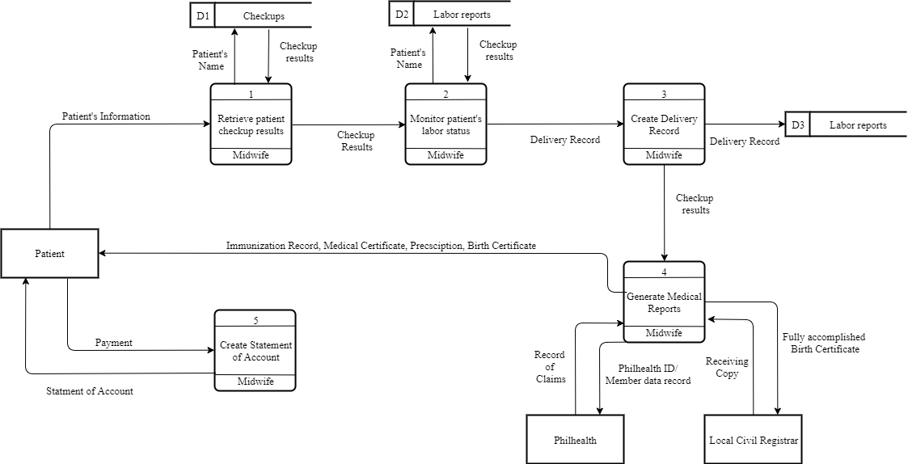

***Figure1***. *Context Level Diagram*

Figure 1 presents the context level diagram of the existing system of Jewel’s First Maternity Clinic. Patient’s records are sent to the manual pen-and-paper system and it will be stored in a file cabinet. Laboratory samples are sent in an external entity and it will receive the laboratory result. PhilHealth and Local Civil Registrar receive data about the pregnant and infant patients.

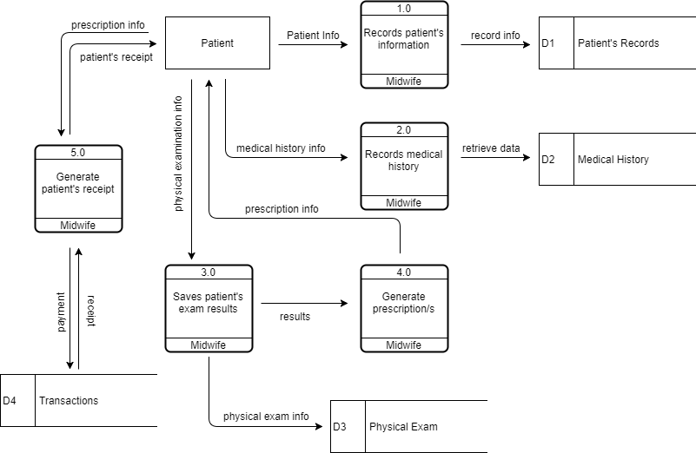

***Figure2.*** *Prenatal checkup process*

Figure 2 shows the prenatal process of old and new patients. New patients will undergo profiling before recording the medical history, physical examination, and to be followed by the prescription and receipt from the clinic. Additionally, the patients will pay the checkup fee.

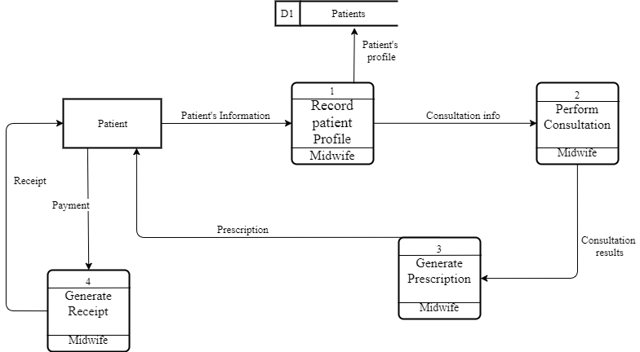

***Figure3.*** *Consultation process*

Figure 3 shows the process of the infant during the consultation process. Clinic’s midwife will retrieve the data of patient in their medical records. After checking patient’s info, consultation process performs. Before generating prescription for patient, consultation results are needed because of data dependency. After receiving the prescription given by the clinic, patent will undergo payment-receipt process.

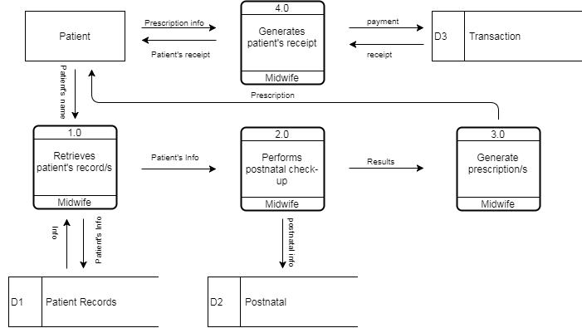

***Figure4.*** *Postnatal Process*

At the end of the quarter of being pregnant the next process is postnatal. Patient’s record will be checked again, if the data exist, midwife will perform postnatal check-up to the patient. Before generating prescriptions, check-up results are needed because of data dependency. Patient receives the prescription and payment-receipt process happens.



***Figure5.*** *Childbirth Process*

After getting pregnant, childbirth process occurs. First again, patient’s record will be retrieve by midwife in their medical records, next, midwife will perform monitoring on patient’s labor status. Delivery record will be created depends on patient’s labor status. Clinic’s midwife will receive check-up results of their patient and medical reports will be generated. Immunization record, medical record, prescription and birth certificate of patient’s child will be given to clinic’s patient.

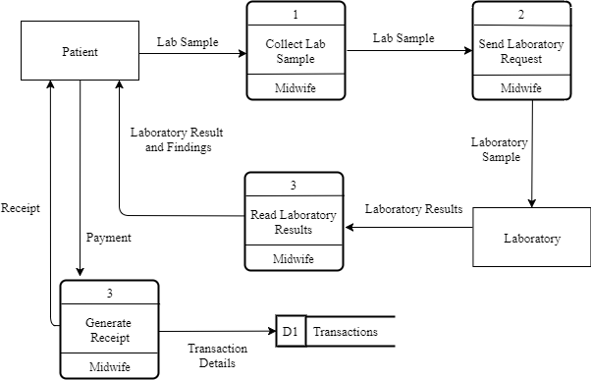

***Figure6.*** *Laboratory request process*

Laboratory request process is a clinical process wherein the patient will undergo some experiments, getting blood platelets and blood pressure. Midwife will collect the patient’s lab sample and will send laboratory request. After examining patient’s lab sample, laboratory will produce results and clinic’s midwife will present it to their patient. Payment-receipt process will be happen after receiving laboratory results.

**Project Development**  
 For the project development, the researchers have decided to use the waterfall method from the System Development Life Cycle (SDLC). Figure 8 shows the detailed flowchart of waterfall method.

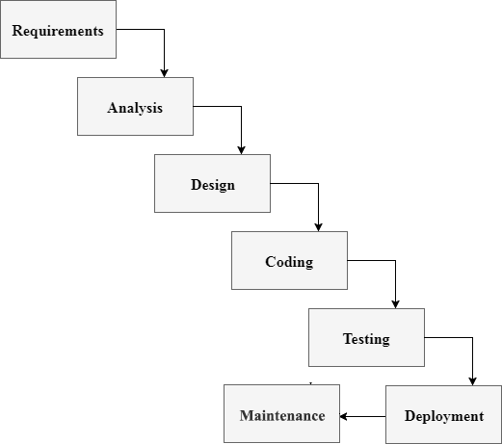

***Figure7.*** *Flowchart for the project development*

1. *Requirements*

Gathering data from a client in development process would actually help the system to reach its desired functionality. Therefore, every system development comes to this, data requirements. In this phase, every data required are gathered as functional and non-functional requirements. It is important because of system’s modules dependency to its client’s information. This will be the basis of input and output process of the system. In clinic patient’s management, data are gathered as planned in order to manipulate the modules inside the system. As the data are given for system’s module as follows; patient record management system, clinic item monitoring system, scheduling system, online appointment, billing system and report generator for medical records , prenatal and postnatal check-up results.

*2. Analysis*

Analysis is detailed examination of the elements or structure of something, typically as a basis for discussion or interpretation. Most of organizations use business process automation to improve workflow and end-to-end business process. This type of strategy begins with an actual analysis of a “physical process” or manual process inside the organization in which the services are done or given. As a dependent phase, it will rely on what is present and dramatically improve the processes by proposing some improvements in order to provide satisfying services. A new technology alone is not enough to say that it is a project success but also endorsing the improvements of business processes inside the organization in such a way that users trust the system and find it easy enough to use. As related in systems analysis, clients will give information about their manual processes and eventually offers automation corresponds to their concern. This will help to provide such services in order to reach their goals in a way that technology is involved.

*3. Design*

In this phase the system and software design is prepared from the requirements specifications which is studied and gathered in the first phase. The system design specifications serve as input for the next phase of the model. In every system development this phase is important because of its functionality and usefulness in creating a system. Data flow diagram (DFD) is a type of business process in which the data is flowing. Inside of it are high level diagram and low level diagram. These processes are shown inside the DFD in where the data gathered are designed as data flows. With relying on client’s data, database designs are created. Database are consisting of multiple of tables wherein the input and output process began. Also, the tables are the container of input data. Without it, the data flow and database design will actually crash.

*4.Coding* In this phase as receiving the system design documents, the work of dividing it into modules and actual coding is started. Since, in this phase the code is produced so it is the main focus for the developer. This is actually the longest phase of software development cycle. Coding phase is actually the creation of the system itself with a dependency in system designs and information. If the design is performed in detailed and organized manner, code generation can be accomplished without much hassle. Every organization has way in using programming languages in order to develop a system. The programming language is chosen with respect to the type of software being developed.

*5. Testing*

In this phase the testing of the developed system happens. Quality assurance is important in order to give a feedback to a developer on which and where the errors occurs. Also, in this phase the communication between the Quality Assurance and Developer becomes more compact because of the improvement of the system that they’re working on. Testing a developed system before it is getting deployed is important in an organization because it is showing the needed improvements before the deployment phase.

*6. Deployment*

The deployment phase is the moment that the system is get tested and ready to be deployed. User Acceptance Testing (UAT) is talking about the deployment of the system in an organization wherein the improvements and debugging are still occurring because of the users’ suggestions and needs. These suggestions are reported directly into the developer team in order to update all the necessary concerns that the user are concern for. After the *beta testing* the actual deployment of the developed system in the market will happens after all the needed and mandatory testing are done.

*7. Maintenance*

Making sure that the application/software is up and running in the respective environment is talking about maintenance. Maintenance is the last phase wherein the system are already deployed and then the actual problems comes up and need to be solved from time to time. Every organization must still have a communication to their client in order to solve each problems and any other concern in their product. This process where the care is taken for the developed product is known as maintenance.

**Use Case Diagram**

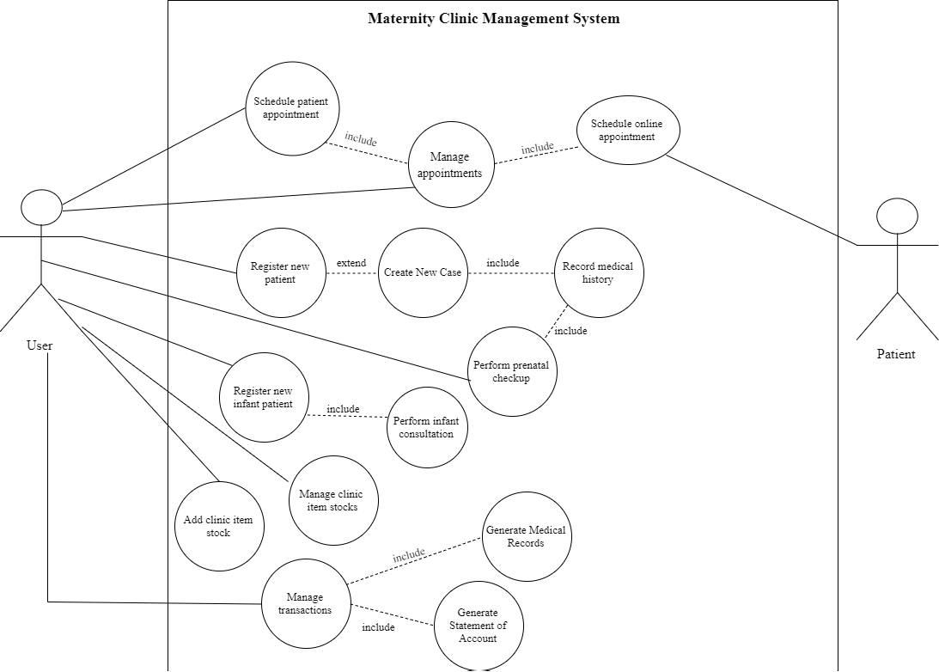

***Figure8.*** *Use Case diagram of the proposed system*

**Database  
 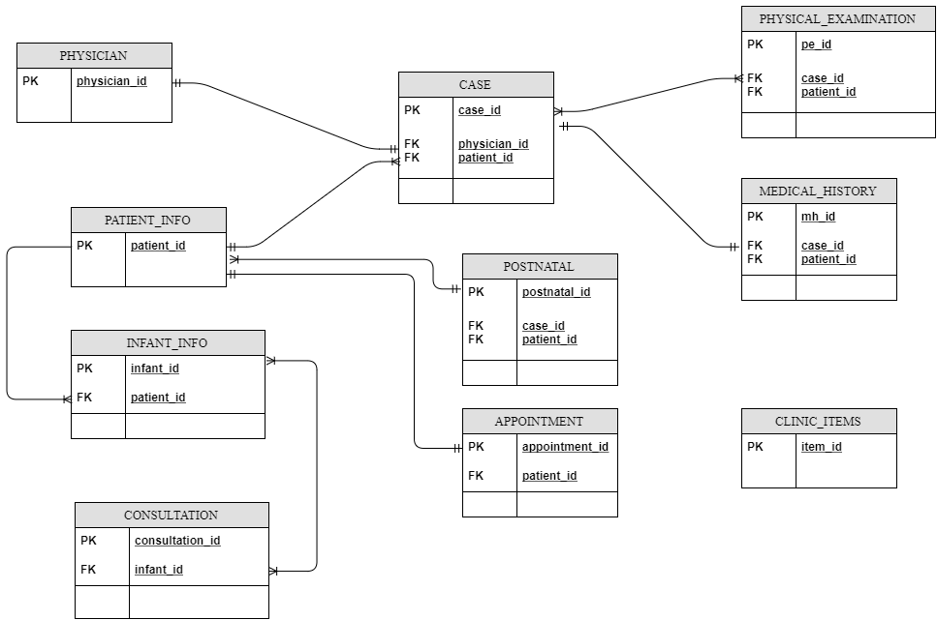**

***Figure9.*** *Entity Relationship Diagram of the proposed system*

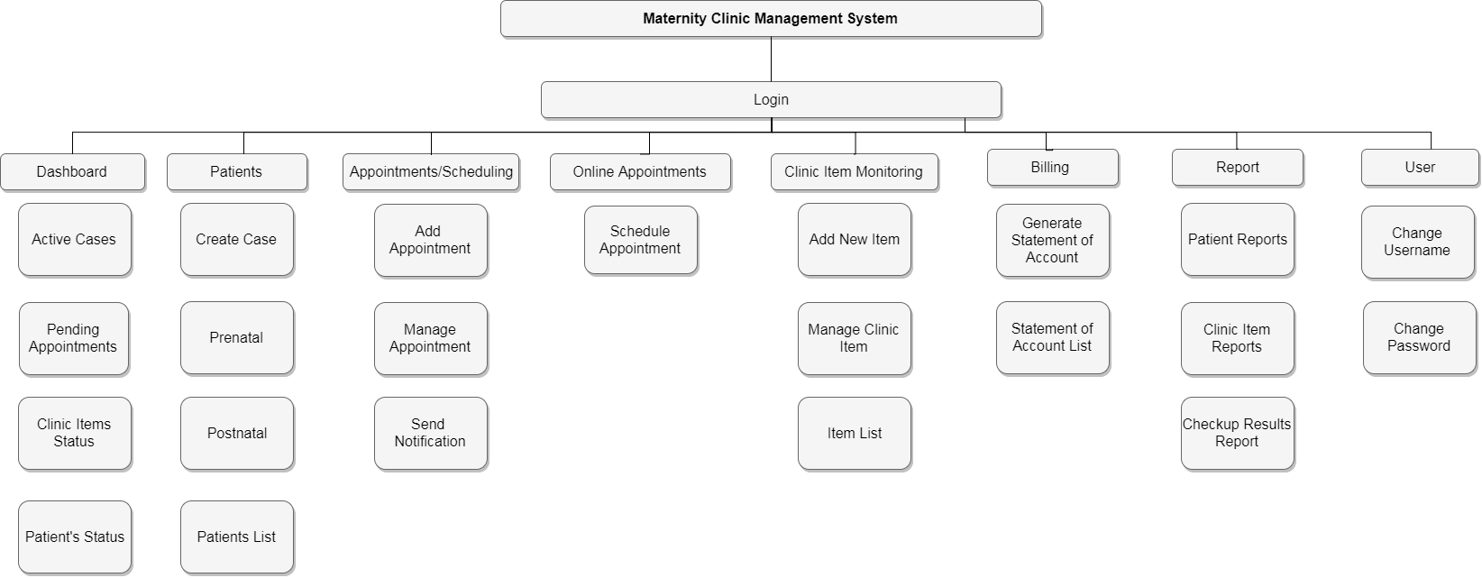**Virtual Table of Contents**  The Virtual Table of Contents (VTOC) represents the hierarchy of data. Figure 2 shows the menus and submenus of Maternity Clinic Management System. Each menu consists of the system’s modules and the submenus consist of the activity in the system.

***Figure10.*** *Virtual Table of Contents of the Proposed System*

**Operation and Testing Procedure** For the operation and testing of the system, the following steps will be conducted by the researchers.

**Table 1***Testing Procedures*

|  |  |  |
| --- | --- | --- |
| Modules | Steps Undertaken | Expected Results |
| Patient record management module | 1. Click “Add New Case”  2. Select “New Patient”  3. Populate required fields for profiling  4. Submit form and proceed to Medical History  5. Populate required fields for Medical History  6. Submit form and proceed to Physical Examination  7. Submit form | An alert message will prompt “New Case Added!” |
| Patient profiles module | 1. Click “Patients” in the navigation bar  2. Search patient’s name in the search bar  3. Click “View Profile” | The system will show the patient’s information, her timeline about the patient’s maternal case, and settings for the profile. |
| Scheduling module | 1. Click “Schedule” in the navigation bar  2. Click “Add new schedule” button  3. populate the required fields  4. select the available time and date  5. submit the form | An alert message will prompt: “New appointment added!” and the appointments in calendar will be updated. |
| Online appointment module | 1. Click “Schedule an appointment” button in the website  2. Populate the required fields  3. Select available time and date  4. Enter the Verification Code that will be sent through SMS  5. Enter the verification code in the text box | An alert message will prompt: “You have now schedule an appointment. Thank you!” |
| Medical report module | 1. Click “Reports” in the navigation bar  2. Search the name of the patient and click “Create medical report” button  3. A modal will appear and click “Prenatal checkup results” button | Check the downloaded .pdf file in the downloads bar of the browser. |
|  |  |  |

Table 1 shows the series of procedures taken during the testing procedure. Each module of the system undergo through a series of steps.